Mod Development Links Compilation - Some links do not work / Formatting broken
forum.kerbalspaceprogram.com/index.php
Here you will find all the necessary tools as well as tutorials, guides and snippets of info relevant to KSP modding.
If you come across any information that you think should be added to this thread please post a reply here.
Before you start:
1. Please visit the General Add-on Affairs forum and check out member requests. It's better if you make something that people actually want.
2. Read all links marked as "Important"
================
Table of Contents
================
1. List of Free and Open Source Tools
1.1 Modding Tools
1.2 Other Tools
2. Not-So-Free Tools
3. Modding Reference Material
4. Modding Information Links
4.1 Common Problems and Solutions
4.2 General Information
4.3 Modelling
4.4 Texturing
4.5 Licensing
4.6 Video Tutorials
4.7 Text Tutorials
4.8 Miscellaneous
4.9 Unity/Configs
4.10 Addons For Modders
4.11 Plugin Development
===============================
List of Free and Open Source Tools
===============================
MODDING TOOLS
Unity - Game engine
This is where you rig, animate, and otherwise set up and compile the part files.
Important - YOU MUST USE UNITY 4.2.2 or earlier. Newer Unity versions do not support legacy animation which are still used by KSP.Part tools:
0.23 Part Tools
thread
Other
FloatCurve Editor
- A unity package for visualising and designing FloatCurves for your configuration files. Also read the
KSP floatCurves guide
MBM to PNG texture converter
- Unity script. Can convert whole folders including subfolders
I recommend you read the 0.23 and 0.20 Part Tools posts by Mu, they are very informative.
If you're having trouble unzipping on a Mac, look here.
Blender - Full featured 3D editor.
Used for creating the 3D assets and animating. Can also be used for texturing, rendering stills and video.
Blender Plugins:
Taniwha's mu Import/Export
MultiEdit
- Allows you to edit a group of separate objects as a single object. Very useful for unwrapping multiple models on a single texture.
KSPBlender
- Blender addon for importing .craft files.
Blender Bundled Plugins:
You might need to enable these in Preferences.
Print3D
- Calculates volume (useful for judging resource capacity) and surface area of mesh objects, as well as does other things useful if you're making models for 3D printing.
GIMP - Raster graphics editor
The best free program for creating textures and other graphics.
GIMP Plugins:
NormalMap plugin
- Generate normal maps from greyscale bump maps.
Krita - Raster graphics editor
Includes some very useful tools not found in GIMP. Check out the features page
.MaPZone - Procedural texture generator
Very powerful texture generator with a compositing interface
DDS4KSP - KSP to DDS texture converter
Use this to allow KSP to load textures faster.
Inkscape - Vector graphics editor
UV layouts exported from Blender can be edited with this. It's also useful as a secondary program for textures if you need to create precision curves.
xNormal - Texture generator
You can generate normals maps, and various masks for your textures.
NVidia Melody - Normal map baking program
Bake normal maps from high-poly models.
NormalMap-Online
Online tool for generating Normal, Displacement, Ambient Occlusion and Specular maps
Meshlab - Mesh editor
You can use this to convert various mesh types.
Notepad++ - Text editor
Use this for editing configuration files. Change language to python to identify bracket pairs and collapse/extend modules.
Hexplorer - Hex editor
You can use this to spec the components of compiled mu files.
DO NOT EDIT FILES
unless you know what you're doing.
OTHER TOOLS
Open Broadcaster Software- Video capture / Streaming
Self explanatory. You can use it to showcase your mod.
Lightworks - Full featured video editing program
Edit and add effects to your videos. Requires registration, however it really is the best free editor out there.
================
Not-So-Free Tools
================
Quixel dDo - Procedural texture generator that adapts to the shape of your model.
The old legacy version is free but it requires Photoshop, which is not free. Link is at the bottom. Direct link
========================
Modding Reference Material
========================
Blender Model Donation - Donate or download unused models started by other forum members.
NASA 3D Resources - Copyright-free models and textures. Important. The models are too high poly to use directly.
Linear aerospike
MiG-105 Spiral photos
Dragon RCS in action
Kennedy Space Center - Lots of great photos of NASA vehicles.
Shuttle flight deck and Shuttle lower deck interactive high-res 360 panoramas.
Launch Photography - Various space- and spacehip-related photos.
Air and Space Museum's Udvar-Hazy Center
Nasa audio - For sound editors. Scroll down for links to huge archives of mission transmissions, rocket and shuttle sounds, and "sounds" of space phenomena.
========================
Modding Information Links
========================
COMMON PROBLEMS AND SOLUTIONS
Invisible mesh / Models not updating
Invisible mesh / Models too small
Stack nodes not attaching
Part with animation not loading
Empty Resource containers have negative cost
Rescaled models revert to original size
Cannot edit/create emissive animations - Unity downgrade tutorial
Infinite resource usage
Curved geometry boolean operations and shader issues / Vertex normals issues - Whole thread is very worth the read.
GENERAL INFORMATION
Stock Parts List
Part Modelling Guidelines - Out of date / almost never updated.
CFG File Documention on the wiki
Modding information page from before the forum wipe - Download of the old page
MODELLING
Kerbal EVA model hierarchy - useful for people who want to modify the Kerbal EVA model / animation itself
Part orientations in the VAB, SPH, and Unity - Image
Part scaling with rescaleFactor
A rough model of a Kerbal for modelling reference
Basic Blender tutorial for making a propellent tank - by Technical ben
Triangle count for parts snippet
Cylinder face numbers
Lots of snippets, read the entire thread
Kerbal stair-climbing ability: staircase step height
KSP vs. Blender coordinate systems - by orson / MKSheppard; in essence, Blender uses Z+/Z- for up/down, but Unity uses Y+ and Y- instead
TEXTURING
MBM to PNG texture converter - Unity script. Can convert whole folders including subfolders
MBMUtilities - Standalone converter. For single or groups of files. MBM to PNG or TGA; TGA or PNG back to MBM
Intermediate Texturing Guide
Intermediate Texturing Guide - Panels and Edge Damage
Texture Format Information - Worth giving the whole thread a read.
Important
DDS Quick Guide - Important Please use DDS!
Fixing texture seams (gaps in the texture on the model)
Memory usage of textures
Creating a normal map
Normal map file naming - Very important with relation to memory usage
Importing models, Generating UV's, Editing and Exporting to .DDS in Photoshop CS6 ext
LICENSING
All addons posted on any official Squad website must have a license - Forum Rule 4.2
License Selection Guide
VIDEO TUTORIALS
Twitch Broadcasts by RoverDude - Lots of videos showing the workflow for part modding from start to finish: Model and Art concept, modelling, animating, UV unwrapping, map baking, texturing stockalike style. Good comments + voiced thoughts.
Tutorial: Unity and Part Tools Setup + Model/Texture Import, Setup and Export to KSP - video by Tiberion
Series by Nifty255
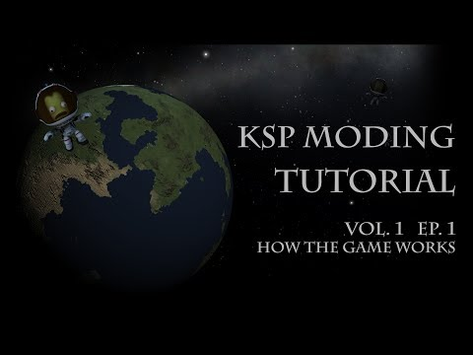https://youtu.be/FypO9m-i6uw
- This covers the very basics.
Vol. 1 Ep. 2 - Game Models and Textures
- This covers proper model and texture setup in Blender, setup and exporting through Unity, and even goes into setting up animations.
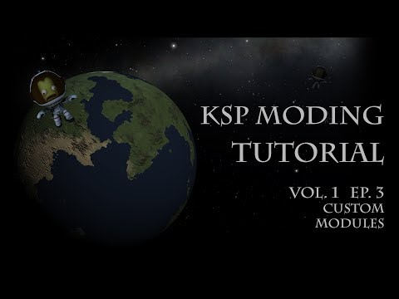https://youtu.be/GxeZDvyT7UY
and
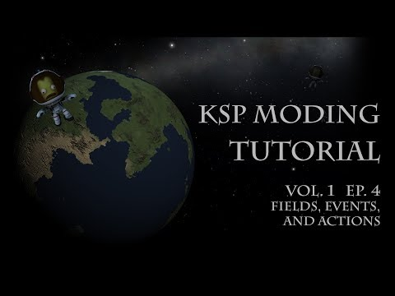https://youtu.be/R90SejwrqVY
- These two cover things on the programming side: modules, plugins, .dlls, etc.
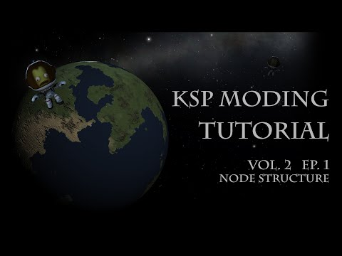https://youtu.be/XqrOVKEj2i0
- How KSP saves and loads its data, from part configs, to ship designs, to entire game saves.
Tutorials by nli2work
Discussion thread
for the following tutorials.
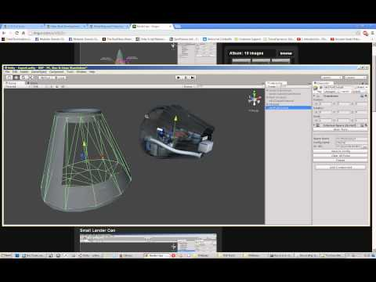https://youtu.be/ux_9tO6PShA
- Exterior/Interior Unity setup; export to KSP; slight config error near the end. ~1hr
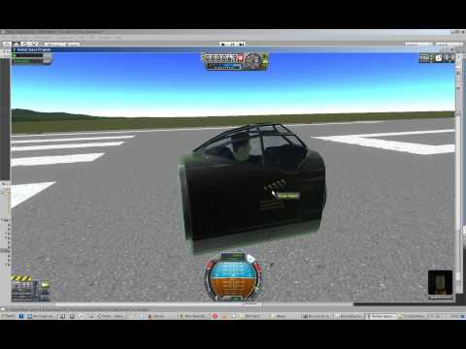https://youtu.be/m8C2-A3qsLk
- Error corrected and explained; External/Internal basic function checks ~15min
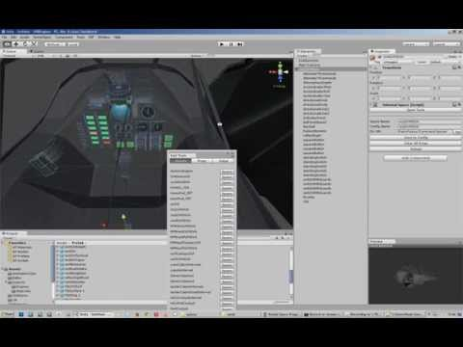https://youtu.be/PrjTcv9WmRQ
- Spawning IVA in Unity; populating IVA with Props and Light ~35m
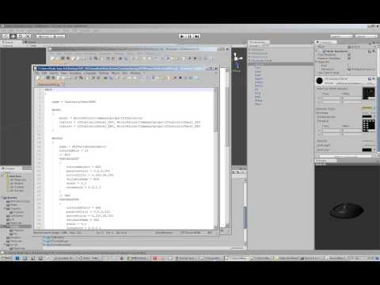https://youtu.be/j-9sNqmnnpA
- Internal Props; ~16min
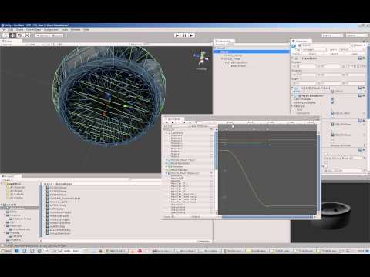https://youtu.be/RPt0bMtj8Yc
- Basic Engine setup; with Emissive, Gimbal, and Fairing
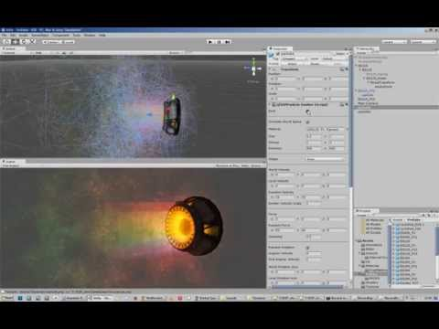https://youtu.be/0mArVHil_ek
- Engine setup with EFFECT{}
Plugin Tutorials by Cybutek
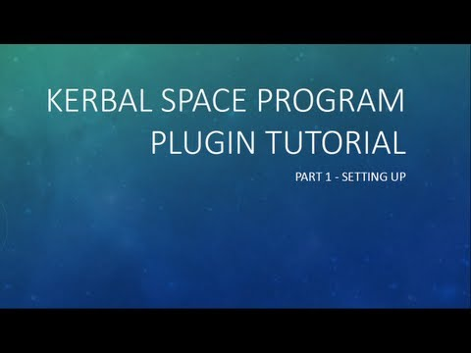https://youtu.be/ilWZjYx7brE
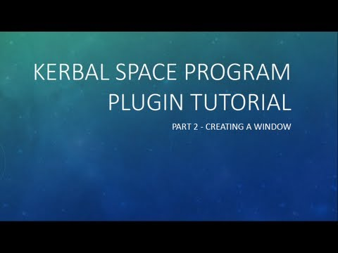https://youtu.be/b-rwQRKz0PM
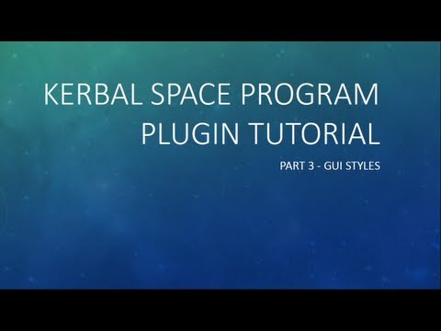https://youtu.be/WpgWnDgwNhM
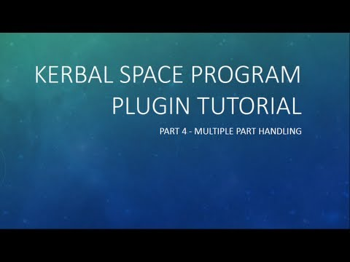https://youtu.be/LJZzkEibn8M
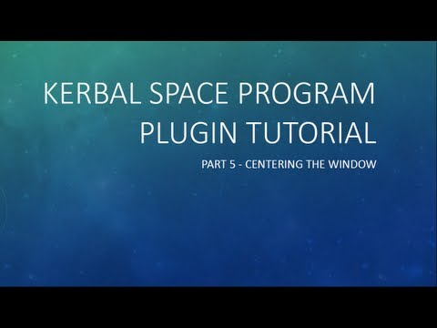https://youtu.be/L7CyUL03ssU
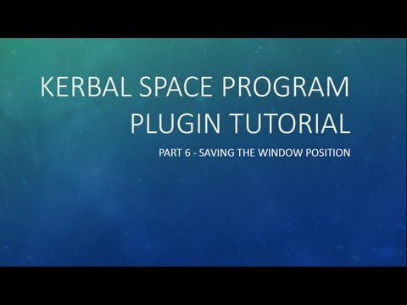https://youtu.be/_qruuunMpHA
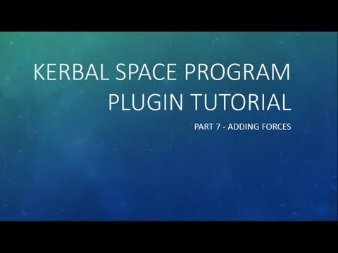https://youtu.be/zHKZPLDdz6k
TEXT TUTORIALS
Making a simple engine in Wings 3D, from start to finish.
MISCELLANEOUS
Official Unity tutorials
Unity Layers and Tags
KSP floatCurves guide - Important for many Part Modules Important
A snippet on ISP and fuel density
Creating a new resource
Stock Parts Costs and Balance Spreadsheet for 0.24
FlagDecal, Docking port IDs, PNG Unity import bug
Unofficial 0.25 modding info
UNITY/CONFIGS
Getting started
Unity to KSP: A Detail Tutorial - written by Kerbtrek
Part Tools 0.20, Blender, Unity and KSP - written by Cheebsta
Example Config file for loading a .Mu file into the game - written by Tiberion
TUTORIAL: Getting Started With Unity - written by Nutt007, includes a video for 0.15
Tutorial:Making and asset from start to finish
Air Intakes
Intakes for jet engines
Intake area explanation
Airlock (Actually a hatch, but it's called an airlock in KSP)
Adding airlocks and ladders to parts - Airlock collider must extend beyond the ladder collider to allow the click menu.
Airlock positioning 1
Airlock positioning 2
Airlock positioning 3
Animation
Blender to Unity animation tutorial - written by Xellith
Exporting an Animation from Blender
Looped animation
Anim Switch details for repeating animation in reverse
Repeating animation in reverse - Old
Start point in animation for VAB snippet
Attach nodes (Radial attachment)
Transform-based NODE{} - New better way. Requires srFix
.Radial attach coordinates - Old way
Tweaking attach nodes snippets - Old way
Collision meshes
Collision Mesh snippets
Normal mesh use
Exploding Kerbals
Cargo Bays
NoAttach tag - Prevents surface attachment for specific colliders.
Contract Testing
ModuleTestSubject
Control Surfaces
Creating a control surface
Decouplers
Decoupler modules
Docking Ports
Adding a docking node in Unity
Stock Docking Port in Unity - Image
Docking port IDs
"Control from here" for docking ports - Useful if your part alignment is different from your docking port direction.
Emissive textures
Emissive tutorial - new thread - written by CardBoardBoxProcessor
Emissive tutorial - old thread - written by CardBoardBoxProcessor
Setting up an emissive on a light - Big pictures
Stopping toggleable emissives showing up lit in VAB/SPH thumbnails
Looping an emissive
Throttle-response emissive snippet
If you have problems with the latest Unity version
Engines
See Video Tutorials above first.
[HOWTO] Airbreathing Engines in KSP 1.0
Quick how-to on setting up a thrustTransform for an Engine
Snippet on thrustTransforms
Unity hierarchy for Gimballing nozzles
ModuleGimbal and ModuleJettison - config settings.
Trouble shooting why an engine might not work
Multiple nozzles
Example - Unity package and compiled part with config.
Engine Fairings
See Video Tutorials above first.
To make fairings in VAB/SPH thumbnail invisible, set the fairing objects tag to Icon_Hidden. You will need to create a new tag to do this.
Example image of the tag
Removing the fairings from stock engines
See above for an example engine.
Flag Decal
Flag decal module
Positioning the decal
GameDatabase
0.20+ specific config extras
IVA
See Video Tutorials above first.
IVA Tutorial - written by TouhouTorpedo - old?
0.17 IVA tutorial - I have no idea if this is still relevant, I've not tried to do any IVA's
Alternate camera for IVA portraits
Stock IVA orientation reference
Ladders
Adding airlocks and ladders to parts
Landing gear
Discussion of a WIP landing gear. Lots of useful information
Stock Landing Gear in Unity - Image
Landing gear snippets - Spread out through the thread
Landing legs
Animated Landing leg w/ suspension tutorial
0.22 Landing Leg module in Unity - Image
Launch stability enhancer / Launch tower
Launch Clamp How-To (Tutorial)
FASA Launch Tower tutorial
Lights
Some tips for setting up lights
Model definition
Replacing "mesh" with "MODEL{}"
Scaling attach nodes with MODEL{}
Parachutes
Stock Parachute in Unity - Image
Components of a parachute
RCS
RCS Tutorial
Rover wheels
Wheel rigging, setup and fault finding - Video tutorial.
Guide with Unity scene example
Stock Rover Wheel in Unity - Image
Changing wheel torque
Science
Science and mods!
Solar Panels
Stock Folding Solar Panels in Unity- Image
Setting up suntracking solar panels
Powercurve explanation
Sounds
Using EFFECTS nodes to play custom sounds
How to get custom sounds to play without a plugin - Pre-0.23 info
Stack nodes
Transform-based NODE{} - Allows you to easily add nodes with transforms. Makes angled nodes easier to implement.
Temperature
Quick guide to temperature rules
Textures and Shaders
Adding a normal map
Faking detail with a normal map
Fixing unwanted texture transparency
Unwanted transparent faces
Potential fixes for incorrect shading
PNG versus TGA loading time
Welding
Example of using 0.20+ MODEL{} modules to combine parts
MODEL{} tutorial - Learn How to Weld! - written by johnsonwax - GONE!
MODEL{} tutorial - Intermediate Welding and Part Scaling - written by johnsonwax
Wings
Wing creation mini tutorial
ADDONS FOR MODDERS
These addons extend the functionality available for mod creators and help with mod development
Tools
DevHelper - Bypass main menu to automatically load any saved game
LoadOnDemand - Important. Loads textures as needed, reducing the memory footprint and speeding up load times without loss of quality. Not actively developed but community fix is available.
ModuleMirror - Mirror symmetry for asymmetrical parts
Part Icon Fixer & Tweaks - Rescales part icons in the VAB and SPH to more appropriate sizes.
RCS Build Aid - Provides visual clues about ship movement under thrust from RCS or engines. Great for if you're making replica ships
srFix - Important. A fix for the currently non-functioning NODE{} HINGE_JOINTs.
Mods
Adaptive Docking Node - Create non-androgynous docking ports or ones that attach to more than one port size/type.
BDArmoury - Includes a .50 cal turret unity package as an example if you want to make your own weapons
Community Resource Pack - Community-defined resources. Check in here before defining a new resource.
Connected Living Space / Config How-To - API for inhabitable areas and passable/impassable parts.
DMagic Module Science Animate - versatile plugin for science experiments
Ferram Aerospace Research / Deriving FAR values for a wing using Blender
Firespitter / Firespitter Module Documentation - various aircraft-related modules as lots of others.
HotRockets! - Particle FX Replacement
Infernal Robotics / How to make robotic parts - Create controllable robotic parts that rotate or translate.
JSIPartUtilities - Let's you toggle meshes and colliders on and off, and other things
Kerbaloons / How to make your own balloon part using KerBalloons - Create baloons
Kethane - Majir restricts the use of some modules
Modular Fuel Tanks - Create user-configurable resource tanks.
Module Manager - allows patching of configs at runtime without overwriting
OpenParticleEmitter - Kethane-derived alternate particles module. Source code only
Open Resource System - Karbonite (An open Kethane alternative) uses this. Also see
Community Resource Pack
Raster Prop Monitor - Configure aircraft and spaceship monitors in IVA
Real Fuels - Makes resources and their measurements based on real science.
SmokeScreen - Extended FX plugin
Texture Animation Util - Scrolls textures on a mesh randomly or smoothly.
Toolbar - Add a visible toollbar button to your plugin
PLUGIN DEVELOPMENT
I would love someone with Plugin experience to point out helpful threads for this
Add-on Posting Rules
CompatibilityChecker - Source code for plugin authors to implement a checker that shows a message if their mod is incompatible with the user's version of KSP and/or Unity
KSP API Documentation
Official PartModule Documentation
Starting out on Plugins
KSP Plugin Framework - Plugin Examples and Structure - by TriggerAu, very recent and up to date
Example plugin projects to help you get started - by TaranisElsu
The official unoffical help a fellow plugin developer thread
Wiki page on Plugins
Creating your first module - on the Wiki
Info on spawning objects and applying gravity - Includes example code, links to more examples, and some useful hints.
How to animate a part with multiple animations?
Great info on Kerbal transforms, bones, rig, FSM, states (ragdoll, idle, sumble, run etc)
Some really good info on writing Unity CG shaders. Even if you're not going to write a custom shader yourself, it still gives you a great insight into what the various bits of the KSP shaders actually control and output.
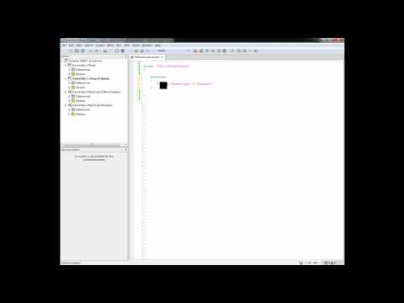https://youtu.be/-IEjJpyPe7I
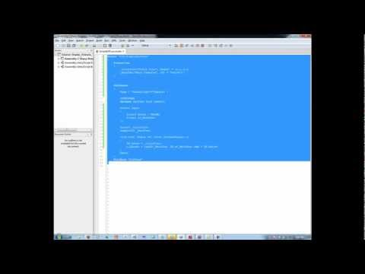https://youtu.be/2eeUDNPjpO8
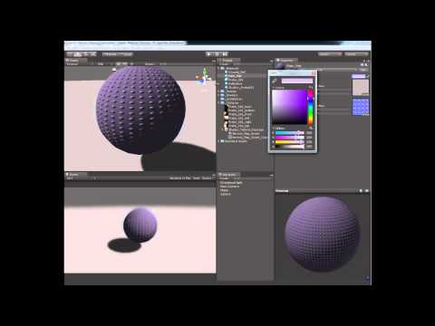https://youtu.be/Lnhc2LJo434
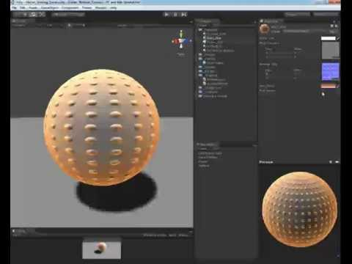https://youtu.be/ajyJGyC34ZE
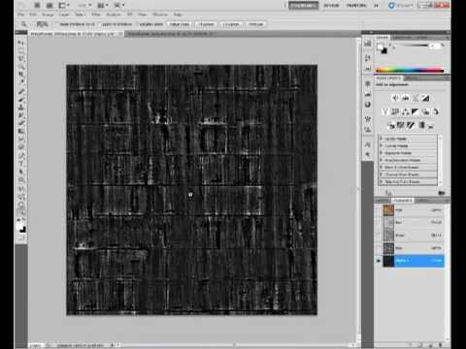https://youtu.be/Tn679djIuI0
Info on loading and using custom shaders into KSP
Misc Plugin Information
Kethane Code Snippet for an incorrect installation warning. Public domain license.
Edited September 5, 2016 by CaptainKipard
Update

